SHIFT:
Sustainability Tips and Future Opportunities

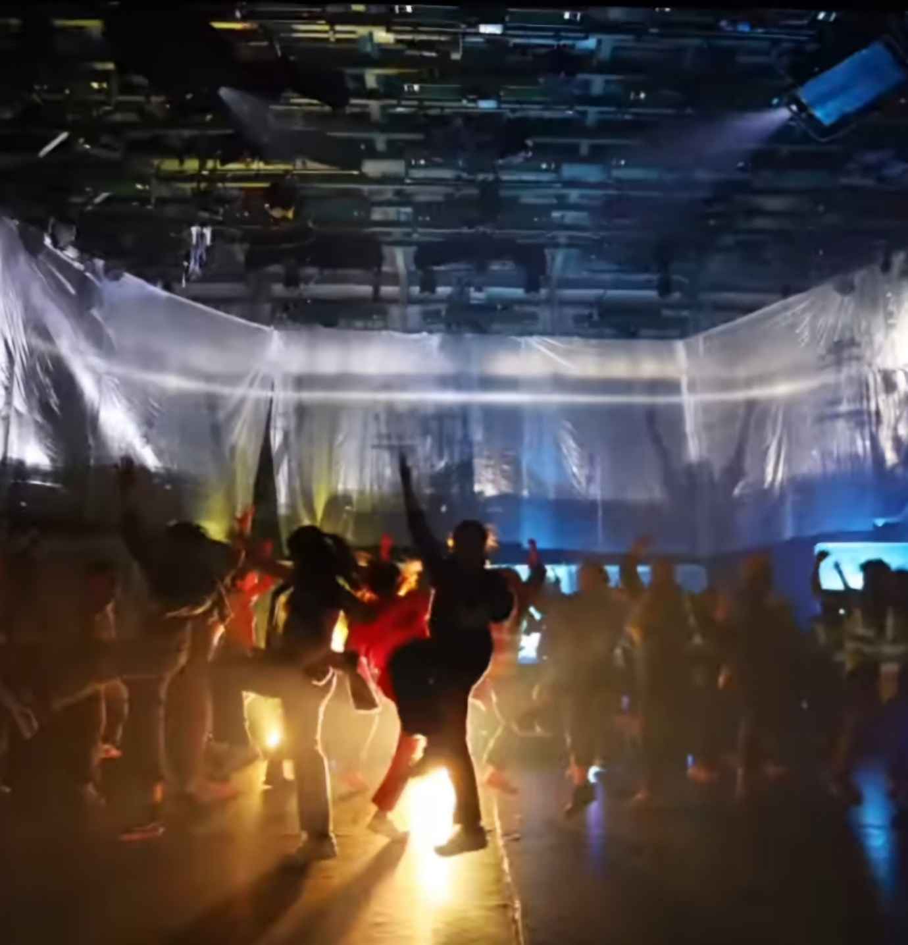

Congratulations on Completing the SHIFT Project!
We're so proud of all the hard work, creativity, and passion you've shown. Now that the project is wrapping up, we want to keep the momentum going by sharing some valuable sustainability tips and ideas on how you can stay involved in making the world a greener, cleaner, fairer and more creative place.

Contents

Get Involved in Sustainability & Eco Art 3 - 5
Upcoming Events 6
Some more Inspirational Projects Combining Arts and Climate 6
Sustainability Tips 7
Know what you are buying 8
Final Thoughts 8
Stay Connected with Us 8

Get Involved in Sustainability & Eco Art
Here are some amazing organisations that you can get involved with:
- Beach of Dreams - a nationwide creative programme featuring new art commissions, creative walks, and events along the coasts of England, Scotland, Northern Ireland, and Wales from 1 May – 1 June 2025. It celebrates and envisions new climate futures for our coastlines and planet.
https://www.beatcarnival.com/beach-of-dreams/
https://beachofdreams.org/become-a-member/

2. Friends of the Earth
- Join this global environmental network to learn more about protecting our planet. They have young people friendly activities and campaigns that you can join to make a difference. Find your local group by searching here:
Join a group near you | Friends of the Earth
They also have projects that they would love groups to jumpstart which can be found here: Steal our ideas Please take the ideas we love but cannot work on | Experiments (friendsoftheearth.uk)

3. The World Wildlife Fund (WWF)
- WWF offers educational resources and campaigns focused on conservation and protecting endangered species. You can even adopt an animal to help support their cause!
https://www.wwf.org.uk/ways-to-help-our-world

4. Eco-Schools
- Is your school part of the Eco-Schools program? If not, why not suggest joining? It’s a great way to start sustainability projects with your classmates and make your school greener.
https://www.eco-schools.org.uk/

5. Climate Action Network
- Get involved in climate action in your area. Look for local chapters that you can join, or find out about campaigns and events you can participate in.
https://climatenetwork.org/

6. Climate Craic
- This project empowers citizen and political action on the climate crisis through inclusive, collaborative, and fun efforts. They aim to unite the community with a celebration of climate action through dance, music, art, and have been running a sustainable festival in Belfast for the past few years! In early stages, they welcome support and enthusiasm—contact them to get involved!
https://climatecraic.com/about/

7. 9ft in Common
- An investigation about ownership, access, disruption and place. 9ft in Common uncovers the complexities and shares the possibilities of an infrastructure of urban alleyways, Belfast’s wild and liminal spaces.
https://9ftincommon.com/

8. Environmental Workshops with ECO-UNESCO
- ECO-UNESCO is a specialist provider of environmental education and youth services in Ireland. Thei environmental workshops are available to schools and youth groups, with each workshop designed to empower young people to learn more about environmental topics in an interactive, positive way which includes fun activities and games appropriately designed for each age group. Topics include Climate Action, sustainable fashion and exploring Ecology & Biodiversity.
https://ecounesco.ie/10-18-youth-programmes/environmental-workshops/

9. Green Foundation Ireland
- Green Foundation Ireland events address issues such as flooding and climate change, food security, and building sustainable communities. GFI events such as seminars and summer schools vary from the very practical, to the philosophical.
http://www.greenfoundationireland.ie/events/

10. Woodland Trust
- The UK's largest woodland conservation charity, their vision is a world where woods and trees thrive for people and nature. Here is a link to their facts and actions for kids page which leads on to their tree planting advice so you can get involved too:
https://www.woodlandtrust.org.uk/blog/2021/10/climate-change-facts-actions-for-kids/

11. Extinction Rebellion
- A global, decentralized movement using non-violent action to push governments on the Climate and Ecological Emergency. They also organize community events like crafts and banner-making for climate protests. Here are links to the Ireland and Northern Ireland sites to sign up for newsletters and local events.
https://extinctionrebellionireland.com/
https://rebellion.global/groups/gb-northern-ireland/

12. Greenpeace
- Greenpeace is a global NGO focused on protecting endangered species, preventing environmental harm, and raising awareness. Through peaceful protests and creative actions, they work to expose environmental issues and promote solutions. Passionate about defending the planet, Greenpeace envisions a greener, healthier, and more peaceful world. Check out their UK and EU sites to connect with local groups and get involved.
https://www.greenpeace.org.uk/
https://www.greenpeace.org/eu-unit/

13. Join the Dots
- An inclusive faith-based network sharing information and working for climate justice in Northern Ireland

https://jointhedotstogether.org/

14. Brink!
A platform for discussion, education and action centred on the issues of climate breakdown. We are driven by creative voices focused on innovative use of technology and citizen science to break through the status quo and consider new ways of living more – connected, healthy, sustainable, and resilient lives – in a rapidly changing environment: https://www.playthinkbrink.com/

15. Keep Northern Ireland Beautiful
- Keep Northern Ireland Beautiful is an independent charity dedicated to creating a cleaner, greener and more sustainable Northern Ireland by delivering on improving environmental education in every school in Northern Ireland, increasing public engagement for communities in need and raising environmental standards for the places where people spend time: where they live, work and relax.

https://www.keepnorthernirelandbeautiful.org
Upcoming Events
1. Local Arts Festivals
- Upcoming arts and culture festivals and events taking place on the island of Ireland. Some celebrate Irish heritage while others explore cultures from further afield, why not support local and check them out?!
The Ultimate Guide To Art And Culture Festivals Ireland 2024 (thelifeofstuff.com)
2. Belfast International Arts Festival
- The 62nd Festival returns 16 October – 23 November 2024 with a new season of contemporary arts and culture in over 30 venues across the city and featuring the very best international and homegrown artists in theatre, dance, music, visual arts, literature and film.
https://belfastinternationalartsfestival.com/2024-festival/
3. Visual Artists Ireland
- A full calendar of events and cultural programmes to be found on the island of Ireland, many which have a sustainability focus. It’s always great to keep an eye on what’s out there to find out about interesting artists who are currently practising or what projects you can get involved in.
https://visualartists.ie/whats-on/
4. Community Arts Partnership
- An independent advocate for community arts and offers the widest possible range of assistance and opportunity to get creative and engage in community-based arts activity. Their website houses events and projects boards full of loads of wonderful things to see and get involved in which is updated weekly. Check out their events and opportunities pages:
https://www.capartscentre.com/category/weekly/events/
https://www.capartscentre.com/category/weekly/opportunities/

Some more Inspirational Projects Combining Arts and Climate-
- TED: 6 public art projects that make climate change up close and personal https://ideas.ted.com/6-public-art-projects-that-make-climate-change-up-close-and-personal/
- ArtFund: How creative collaborations are fighting climate change
https://www.artfund.org/explore/get-inspired/features/how-creative-collaborations-are-fighting-climate-change
- British Council: Creative Commissions for Climate Action
https://www.britishcouncil.org/arts/culture-development/our-stories/creative-commissions
- Creative Ireland – Creativity & Climate Projects
https://www.creativeireland.gov.ie/en/creative-pillars/?category=creativity-and-climate-change#posts
- Climate Change Resources for Young People
https://climatechangeresources.org/youth/just-for-kids/

Sustainability Tips
1. Refuse, Reduce, Reuse, Repurpose, Recycle
- Refuse: Do you really need the product? Be careful of advertising or social media pressure to encourage you to buy things (e.g. clothes) you do not really need.
- Reduce: Think about the waste you create. Can you use less packaging or avoid single-use plastics?
- Reuse: Get creative! Turn old clothes into costumes or use scrap materials for your next art project. Buy second-hand, buy vintage.
- Repurpose: For items that can't be refused, reduced, or reused, try repurposing it. Many people in the green community refer to this method as upcycling. You may be surprised to learn how many common products serve more than one purpose. Sometimes it requires using some creativity, but the possibilities are endless.
- Recycle: Make sure you’re recycling paper, plastics, and glass correctly and composting your food waste. Check your local guidelines to see what can and can’t be recycled.
2. Choose Plant-Based Meals
- Eating plant-based even just a few times a week can greatly reduce your carbon footprint. Why not try a new veggie recipe with your family? Or reduce meals based around red meat (which has a high carbon impact as well as on animal welfare).
3. Save Energy
- Remember to turn off lights when you leave a room and unplug devices when they’re not in use. Use a blanket or put on a jumper rather than putting on the heating for the whole house for example. Every little bit helps conserve energy.
4. Use Water Wisely
- Turn off the tap while brushing your teeth, and take shorter showers to save water.
5. Support Local- ‘Put Your Money Where Your House Is’
- Choose to buy from local shops and eat at locally-owned cafés and restaurants. Supporting local businesses reduces transportation emissions, keeps money within the local economy and helps your community thrive.
6. Active Travel
- Minimise travel by car – where possible take public transport (bus, train, tram) or ‘active travel’ options such as cycling or walking. Or can you ‘work from home’ and so avoid travel altogether? Can you take a ferry and train rather than fly? If you have to fly consider ‘carbon offsetting’ the carbon emissions produced by your flight.
7. Educate yourself!
Learn more about the climate and ecological crisis – their causes, impacts and solutions and how responsibility for the causes of the crisis are not shared by everyone (rich people and their consumption are more responsible than poor people for example) and the impacts of the crisis are not equally experienced by everyone around the world (communities in the global south neither have caused the crisis but experience some of the worse impacts).

Know what you are buying – some websites and apps
https://ethicalrevolution.co.uk/
https://www.ethicalconsumer.org/retailers
https://goodonyou.eco/ (Fashion only)

Final Thoughts
We hope you enjoy the resources in this pack, but remember, this list is non-exhaustive and just a starting point for the possibilities out there. Many arts organisations run projects with a sustainability focus and we encourage you to do your own research to find further eco arts opportunities and more sustainability inspiration! The actions you take today can have a big impact on the future. By staying involved and continuing to make eco-friendly choices, you’re helping to create a healthier, more sustainable world. Keep being creative, stay curious, and remember: every small step counts!
Thank you for being a part of SHIFT, and for your commitment to making the world a greener place. We can’t wait to see what you’ll do next!

Stay Connected with Us:
- Follow us on social media for updates on future projects and more sustainability tips:
  - Instagram: @du.dance.ni
  - Facebook: DU Dance (NI)
  - Twitter: @dudanceni
Keep up the great work, and let’s continue to make a difference together!

